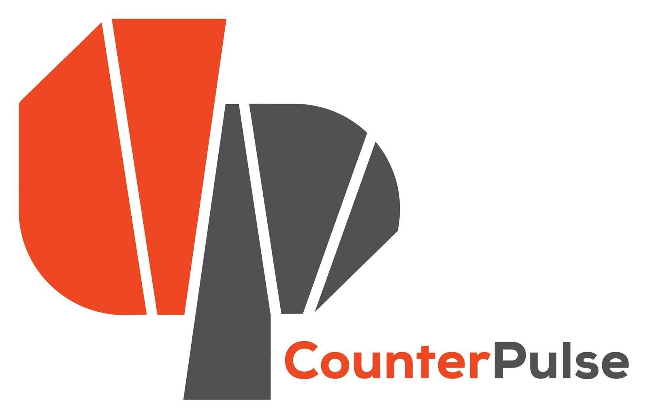 | Performance/Technology Combustible Residency  Letter of Intent  Deadline: Friday, December 6th, 11:59PM, 2019  Residency Period: March - August 2020 (Final Schedule TBD)  Performance Dates: Fall 2020 (TBD)  Artist Stipend: $1,500 + portion of box office income

NAME OF APPLICANT: COMPANY NAME (IF APPLICABLE):
ADDRESS: CITY: STATE: ZIP CODE:
PHONE: EMAIL: WEBSITE:

PROPOSAL INSTRUCTIONS:
- *** Save a copy in Google Drive [File-> Make a Copy] or MS Word, using the following labeling system: “YourName_ARCC2020_LOI”, for example: JustineFernandez_ARCC2020_LOI
- Complete this Letter of Intent form. Responses should not be more than 2 pages, single-space, 11pt.
- Save your application in PDF of Google Doc or MS Word applications.
- Email your PDF application to Min Yoon: min@counterpulse.org
- If you have any questions please contact min@counterpulse.org
- Please do not submit any additional materials with your application.

CURATORIAL PHILOSOPHY: Combustible is part of CounterPulse’s ongoing Artist Residency program (ARC). At its core the ARC program yields to emergent ideas from independent artists in the field. As such the curatorial directions of the program are responsive and ever changing. In tandem with this strategic impressionability, the program seeks work that is saturated with the values of relevance, transformation and innovation. Work that is nuanced and self-aware of the ways in which it is contextualized by and gives context to social, political, economic or environmental issues and phenomena are strong fits for the program.

Combustible is a lab for intersecting art practices from dance and technology. Artists are given space and time for the creation of innovative projects with the use of our state-of-the-art arts center. Throughout a residency period artists share their research through designed public experiences and events. Combustible carves a place to be deeply inquisitive and experiment on the edge of what is known. In the past this residency required collaboration between a choreographer and a creative technologist. This year we remove that requirement, but still strongly encourage multidisciplinary collaboration. Projects still must include creative technology or new media as well as dance or performance. Another change this year is that we’re interested in a broader range of projects formats—time-based works for stage as well as immersive installations will be considered.

The Combustible Residency invites artists to ask: How can current technological tools be employed to create live performances/experiences that powerfully reflect today’s world? How can the potential of body-based performance be used to generate an excellent live art experience? Bear these provocations in mind as you compose your Letter of Intent.
Please highlights ways in which your work:
- Inspires new audiences to engage with live performance.
- Has a distinct vision for using CounterPulse’s physical space and organizational resources. Artists may choose to present works in our Main Stage Theater of Project Space Gallery.
- Is interested in engaging the public in your process of creation—through the process showings, blog writing and artist interviews that are part of this residency.
- Employs technological tools and body-based performance to generate an excellent live art experience.
1. Describe your work and artistic / technical background. Please include links to your portfolio / resume / urls.

2. Describe the technological tools / new media you are interested in working with as well as any collaborators you have or may need.

3. Describe the piece you would like to develop during your residency and if you are interested in making work for our main stage theater or project space gallery.

4. Why are you interested in working at CounterPulse?

5. Work Samples: You may submit up to 2 video samples of past performance work that total no more than 10 minutes or samples of creative tech projects. Please provide context for your work sample(s). Does this represent the type of work that you are proposing? Is this a Work-in-Progress or a finished piece?

6. How did you hear about this opportunity?

