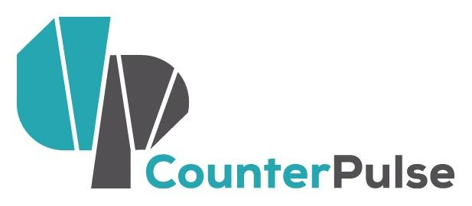 | Block Fest Artist Activators  Letter of Intent: 2017-2018  Deadline: MAY 31, 2017  Activity Period: First Fridays Sept 2017 - June 2018

NAME OF APPLICANT/ CONTACT PERSON:
NAME OF COMPANY (IF APPLICABLE):
ADDRESS:
CITY: STATE: ZIP:
PHONE: EMAIL: WEBSITE:

Project: The Artist Activator public art opportunity is for artists working in and with the communities of the Tenderloin, or with interest in doing so. Artist Activators will partner with CounterPulse, Central City S.R.O. Collaborative (CCSROC) and Tenderloin residents to design projects to feature at a monthly Block Fest on Turk Street between Mason Street and Taylor Street. Every first Friday of the month from 3PM-4:30PM CounterPulse, CCSROC, and Artist Activators will animate the block with art, culture, and community with Block Fest. We hope to celebrate what makes the Tenderloin special, elevate underheard community concerns, and engage our neighbors in art-making and sharing.

Artists will receive a stipend of $1,500, a $500 supply budget, and administration and production support from CounterPulse and CCSROC. Block Fest projects projects/activities will occur outdoors in the 23’ wide x 4’ deep x 9’ high front alcove and entryway of CounterPulse or on the sidewalk space in front of CCSROC.

We welcome artists of all disciplines, but we highly encourage artists who live and work in the Tenderloin to apply. This opportunity is designed for artists who:

- Strive to eliminate boundaries between disciplines, artists and audience, and divergent communities.
- Include public interaction and engagement as part of their creative process
- Value the social-bond and empathy building power of arts experiences
- Are self-starting and able to thrive in a DIY environment
- Have vision for the arts as a tool for social justice and community action

PLEASE NOTE: Block Fest Artist Activators who have participated in Block Fest must wait one year before applying to Block Fest again.
Save the date for our Open Calls Mixer on Friday April 21, 6-7:30pm at CounterPulse, 80 Turk St. Come learn about Block Fest and other upcoming artist opportunities!

The Letter of Intent form begins on the next page. Please complete the form and submit using the instructions below to be considered.

If you have any questions or concerns please contact rick@counterpulse.org

LETTER OF INTENT INSTRUCTIONS:
- Fill in your contact information on page 1.
- Complete this Letter of Intent form below, answering each question as completely as possible within word limits.
- Letters of Intent will be accepted via email or in hard copy.
- Please do not submit any additional materials with your application.
- To submit via email:
  - Save your document using the following labeling system: “YourName_BlockFest_LOI_2016.”
  - Save your application either in Microsoft Word or PDF format.
  - Email your application to Rick Darnell: rick@counterpulse.org
- To submit in hard copy:
  - Print your completed Letter of Intent
  - Drop-off your Letter of Intent at CounterPulse (80 Turk Street) or CCSROC (48 Turk Street).
  - Mail your Letter of Intent to:
CounterPulse
attn: Rick Darnell, Community Engagement Associate
80 Turk Street
San Francisco, CA 94102

- Letters of Intent must be received (not postmarked) by 5PM MONDAY, MAY 31, 2017

Describe your work and artistic background. (200 Word Max)

Describe the project you would like to present through Block Fest. (300 word max)

What are the technical needs of your project and would a $500 supply budget be used? (100 words max)

Describe your relationship to the Tenderloin, and how your project serves our neighborhood? (300 words max)

Block Fest is scheduled for the afternoon of the first Friday of the month. Please indicate at least two months that you are available September 2017 through June 2018. Discuss other availability concerns we should be aware of. (100 words max)

Work Sample: Please provide URL links (preferred) of past or current work that represents your proposed project. You may submit:
- up to 10 minutes of video or audio samples
- up to 4 photographs of, or articles about your work
- a combination of 5 minutes video or audio and 2 photographs or articles

Please provide context for your work sample(s). Does the work represent the type of work that you are proposing? Is this a work-in-progress, or a finished piece? (200 words max)

If you have any questions contact Rick Darnell, rick@counterpulse.org or call the CounterPulse office (415) 626-2060 Monday, Wednesday, Thursday, or Friday, 10am to 4pm.

Please email this form to Rick Darnell: rick@counterpulse.org or submit a hard copy to the CounterPulse Office (80 Turk St) or Central City S.R.O. Collaborative Office (48 Turk St) by 5PM Wednesday, May 31, 2017

